**QUERIES**

select * from tab;

CREATE TABLE PERSON (DRIVER_ID VARCHAR2(10),NAME VARCHAR2(20),ADDRESS VARCHAR2(15),PRIMARY KEY(DRIVER_ID));

CREATE TABLE CAR (REGNO VARCHAR2(10),MODEL VARCHAR2(10),YEAR NUMBER(4),PRIMARY KEY(REGNO));

CREATE TABLE ACCIDENT (REPORT_NO NUMBER(5),ADATE DATE, LOCATION VARCHAR2(15),PRIMARY KEY(REPORT_NO));

CREATE TABLE OWNS (DRIVER_ID VARCHAR2(10),REGNO VARCHAR2(10),PRIMARY KEY(DRIVER_ID,REGNO),FOREIGN KEY(DRIVER_ID) REFERENCES PERSON(DRIVER_ID),FOREIGN KEY(REGNO) REFERENCES CAR(REGNO));

CREATE TABLE PARTICIPATED (DRIVER_ID VARCHAR2(10),REGNO VARCHAR2(10),REPORT_NO NUMBER(5),DAMAGE_AMT NUMBER(7,2),PRIMARY KEY(DRIVER_ID,REGNO,REPORT_NO),FOREIGN KEY(DRIVER_ID,REGNO) REFERENCES OWNS(DRIVER_ID,REGNO) ON DELETE CASCADE,FOREIGN KEY(REPORT_NO) REFERENCES ACCIDENT(REPORT_NO) ON DELETE CASCADE);

INSERT INTO PERSON VALUES('&DRIVER_ID','&NAME','&ADDRESS');

SELECT * FROM PERSON;

INSERT INTO CAR VALUES('&REGNO','&MODEL','&YEAR');

SELECT * FROM CAR;

INSERT INTO ACCIDENT VALUES(&REPORT_NO,'&DATE','&LOCATION');

SELECT * FROM ACCIDENT;

INSERT INTO OWNS VALUES('&DRIVER_ID','&REGNO');

SELECT * FROM OWNS;

INSERT INTO PARTICIPATED VALUES('&DRIVER_ID','&REGNO','&REPORT_NO','&DAMAGE_AMT');

SELECT * FROM PARTICIPATED;

UPDATE PARTICIPATED SET DAMAGE_AMT=25000 WHERE REPORT_NO=12 AND REGNO='KA04Q2301';

SELECT COUNT (*) FROM ACCIDENT WHERE ADATE LIKE'__-__-02';

SELECT COUNT(A.REPORT_NO) FROM ACCIDENT A,PARTICIPATED P,CAR C WHERE A.REPORT_NO=P.REPORT_NO AND P.REGNO=C.REGNO AND C.MODEL='MARUTHI-DX';

**OUTPUT**

**1.PERSON TABLE**

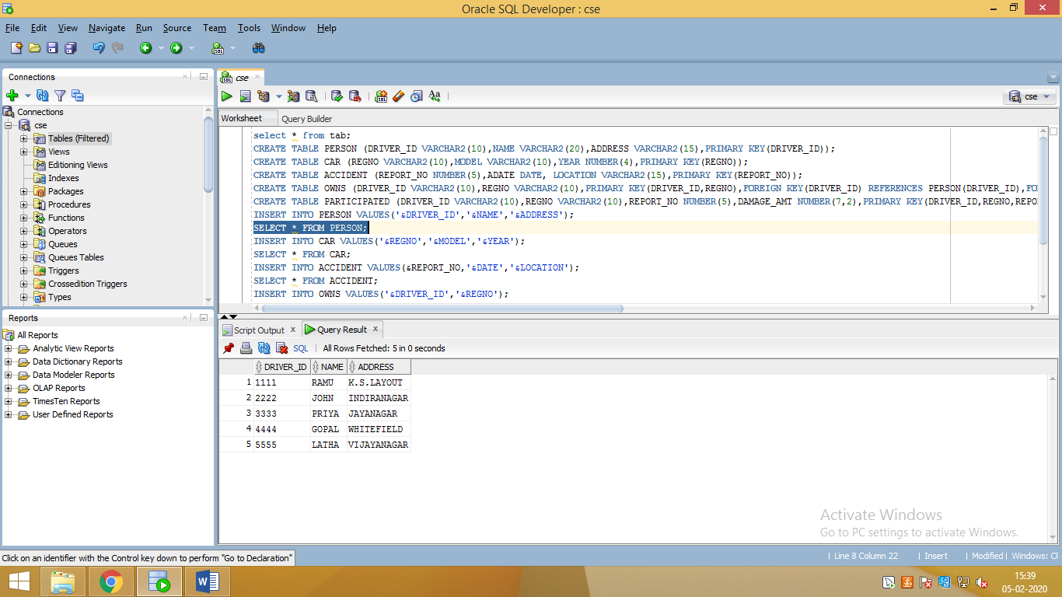

**2. CAR**

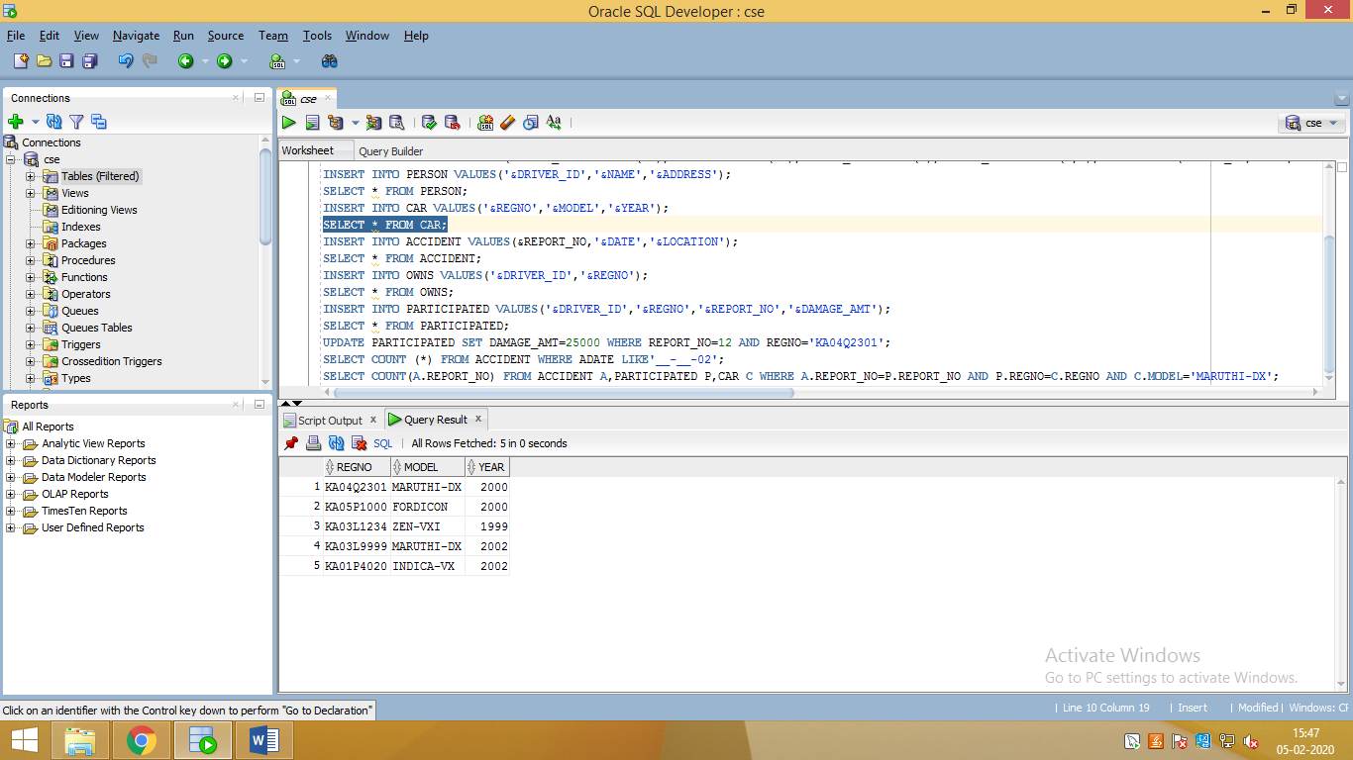

**3. ACCIDENT**

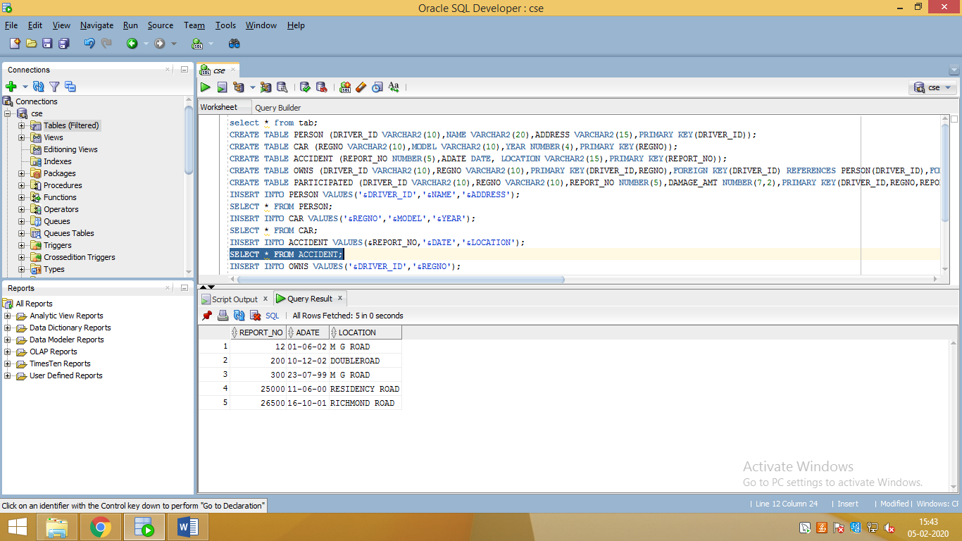

**4. OWNS**

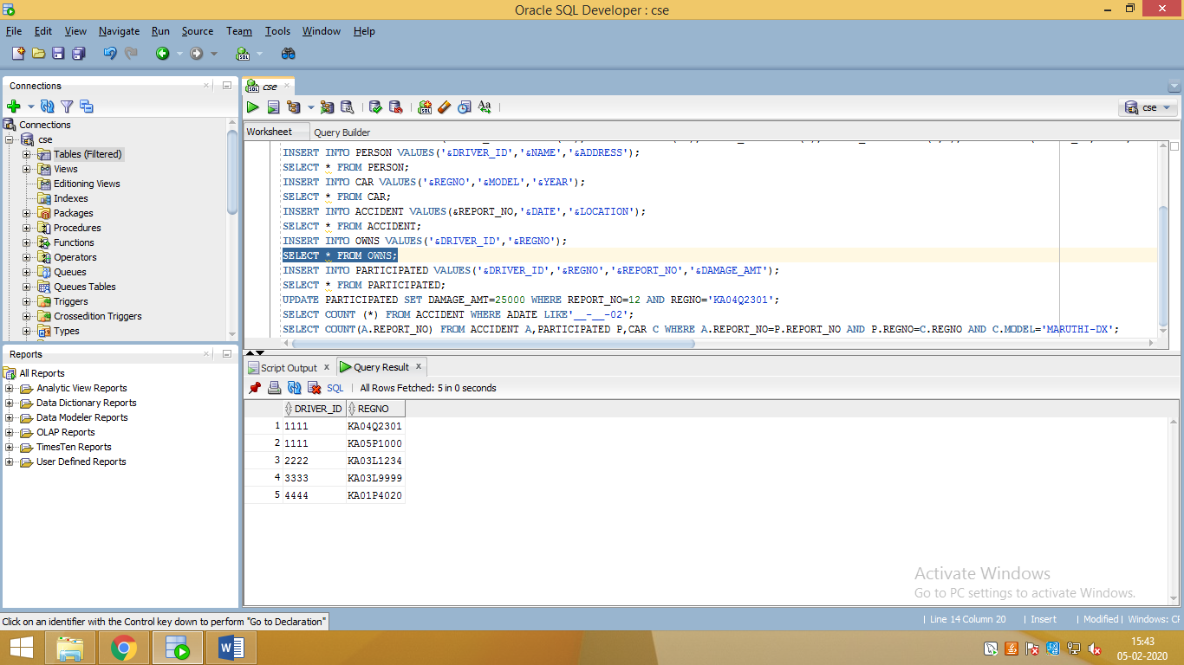

**5. PARTICIPATED**

